https://doi.org/10.23913/ricsh.v15i29.392
Artículos científicos
Liquid Housing and Hidden Homelessness: Policy Innovation through Co-Creation in Tarragona
Vivienda líquida y sinhogarismo oculto: Innovación en políticas urbanas mediante co-creación en Tarragona
Habitação líquida e sem-teto invisível: Inovação em políticas urbanas por meio da cocriação em Tarragona

Héctor Simón Moreno
Profesor Agregado de Derecho Civil y Director de la Cátedra UNESCO de Vivienda de la Universidad Rovira i Virgili
hector.simon@urv.cat

Abstract
The phenomenon of “liquid housing” represents one of the most pressing challenges for contemporary housing policy in European cities. Defined by forms of housing insecurity such as squatting, illegal subletting, forced shared occupancy, overcrowded or substandard housing, liquid housing blurs boundaries between stability and homelessness. With an emphasis on the policy co-creation process, this research draws upon mixed methods, including surveys, stakeholder interviews, and scenario-based workshops to generate actionable evidence, foster multi-level stakeholder engagement, and co-create local policy solutions in response to the multifaceted challenge of liquid housing. The findings reveal the centrality of data-driven awareness, stakeholder integration, and governance reform for achieving resilient, inclusive policy innovation in the context of fragmented competences and persistent social vulnerability. The article concludes that sustained progress against liquid housing demands a holistic, rights-based, and cross-sectoral approach, rooted in collaborative intelligence and empowered civic participation, to ensure dignified housing for all in medium-sized cities such as Tarragona, the city aimed by the study.
Keywords: Liquid housing, hidden homelessness, co-creation, scenario planning, housing policy, participatory governance

Resumen
El fenómeno de la “vivienda líquida” (“Liquid Housing”) representa uno de los desafíos más urgentes para la política de vivienda contemporánea en las ciudades europeas. Definida por formas de inseguridad habitacional como la okupación ilegal, el subarriendo ilícito, la cohabitación forzada, el hacinamiento o la vivienda en condiciones deficientes, la vivienda líquida difumina los límites entre la estabilidad y la falta de hogar. Con énfasis en el proceso de co-creación de políticas, esta investigación se basa en métodos mixtos, incluyendo encuestas, entrevistas con actores clave y talleres basados en escenarios, para generar evidencia aplicable, fomentar la participación de múltiples niveles de actores y co-crear soluciones de política local en respuesta al desafío multifacético de la “vivienda líquida”. Los hallazgos revelan la necesaria actuación basada en datos, integración de actores y reforma de la gobernanza para lograr una innovación política resiliente e inclusiva en un contexto de competencias fragmentadas y vulnerabilidad social persistente. El artículo concluye que las actuaciones frente a la vivienda líquida exigen un enfoque holístico, basado en derechos y transversal, arraigado en la inteligencia colaborativa y la participación ciudadana empoderada, para garantizar una vivienda digna para todos en ciudades de tamaño medio como Tarragona, la ciudad objeto del estudio.
Palabras clave: Vivienda Líquida, sinhogarismo oculto, co-creación, proyección de escenarios, políticas de vivienda, gobernanza participative

1. Introduction
Certainty in our time, for many reasons, is scarce. Bauman (2000) popularized the expression “liquid modernity” to refer to the process of progressive melting of structural, societal, institutional, and economic foundations and pillars during the years prior to the Global Financial Crisis 2007 (GFC2007), but that can be applied to what is happening to housing today. The GFC2007 is still having a severe impact on European citizens, which is now combined with the effects of COVID19 (2020-2021) and the inflation crises (2022): households are increasingly suffering from over-indebtedness, due to the unaffordability of housing in urban areas, resulting in evictions (Kenna et al, 2016). Indeed, a constant process of urbanisation, i.e. population concentration in big cities, with a supply that is several times constrained by land scarcity, coupled with the process of emptying of rural space and the lack of social and affordable housing has contributed to housing unaffordability in major urban areas in EU MS (Nasarre-Aznar et al., 2021). But this is only one part of the current reality. The line between what real “housing” is (once clear in terms of title, stability, quality, and adequacy) and what is just “provisional shelter” is now becoming increasingly blurry.
Thus, this paper focuses precisely on this second bunch of consequences, arising from the three aforementioned crises/shocks, which all share the characteristic of being part of the “liquid housing” concept (i.e., meaning that basically everything is suitable to be considered as “adequate housing”). More specifically, several forms of “liquid housing” have proliferated in several different EU member states (EU MS) such as squatting, the illegal subletting of housing, short-term (excluding holiday rentals) rental accommodation and overcrowded and/or substandard housing.
As a result, these crises/shocks have impacted the human right to housing. Indeed, from the right to housing perspective, security of tenure (especially private ownership, but also properly regulated tenancies or cooperatives) is the cornerstone of the right to adequate housing (Articles 25 UDHR 1948 and 11 ICESCR 1966). Although liquid housing may take different forms in each EU MS (see below), it is undeniably a pan-European phenomenon involving several challenges: housing as a human right, gentrification and concentration of population in urban centres and peripheries facing inadequate housing. In Spain, and particularly in the city of Tarragona, these challenges are acutely visible. In the aftermath of the 2008 financial crisis, years of austerity, a weakened welfare state, and renewed migration flows have both exposed and exacerbated housing vulnerabilities. Multilevel public housing policies in Spain have been erratic in all these areas in recent years leading to a progressive precariousness of the land tenure and to the increase (and, even, its promotion by public authorities) of situations of hidden homelessness (Nasarre Aznar, 2020 and 2025). In this context, an experimental, action-research initiative, was launched in 2024-2025 to generate empirical evidence, foster robust community engagement, and co-create viable policy responses to the liquid housing phenomenon in the intermediate city of Tarragona (Spain).
First the concept of liquid housing is explained, then the methodological approach and the findings are outlined. Finally, the paper stresses the importance of addressing the liquid housing phenomenon from a holistic perspective and provides recommendations to policy makers.

1.1 Literature review and conceptual framework
The growth and persistence of “liquid housing” phenomena must be situated within the evolving scholarly landscape that examines contemporary housing vulnerability, exclusion, and resilience. The term “liquid housing” itself is an explicit reference to Bauman’s (2000) broader thesis of social ‘liquidity’: under late modernity, once-stable socioeconomic categories and institutions have become fluid, uncertain, and unstable, including the forms and pathways of housing exclusion. Examples of the “liquid housing” phenomenon are the following:
a) Squatters on public or private land/flats without any kind of legal rights have increased in countries like Spain (there are currently estimated to be around 78,800 dwellings (Institut Cerdà, 2023). In fact, estimates suggest that the squatter population has grown worldwide since 2007 due to the adverse economic effects of the various crises (Manjikian, 2013).
b) The illegal subletting of housing, which leads to the existence of black-market tenancies, i.e., informal, unofficial agreements, violating basic public or private law rules. Sub-tenants are in a weak legal position against the owner of the dwelling, who may initiate eviction proceedings (“silent evictions”). As a matter of fact, this category might include cases of tenants who, while not homeless or roofless, suffer from substandard, insecure or otherwise inadequate housing. These tenures encompass not only squatting but also other situations such as property guardianship (Ferreri et al., 2016), gratuitous housing loans (commodatum, typically among relatives), people forced to shared housing (a stratification process based on the differentiation between socio-economic conditions, coupled with the form of sharing, so poor people tend towards insecure living arrangements, while “premium” co-living is located in wealthy neighborhoods, Grundström, et al., 2024) and informal, ‘black market’ occupancies, that is, tenancies with illegal elements such as tax violations, or a failure to comply with registration or habitability requirements, which are governed by informal extralegal agreements (literature shows that non-commercial shared housing is not accommodated well in existing housing policy systems, Goodall et al., 2023). This phenomenon is present mainly in Eastern EU MS (Schmid, 2018), but is also present in other countries such as Spain (the phenomena of “silent evictions” of families renting from landlords who are not the real owner is a reality in Barcelona, Caballé et al., 2020).
c) Short-term (excluding holiday rentals) rental accommodation, which is sometimes not declared (this is partially attributable to platforms that hide the identities of hosts and the precise locations of illegal listings and systematically fail to verify host identities and locations (Cox and Haar, 2020) and may be used to evade the law, i.e. trying to avoid those non-negotiable legal dispositions that usually only protect residential tenants, but not other types of tenants, such as short-term renters; thus, landlords qualify their tenants as “non-residential” while their need for housing is really residential, and therefore avoid having to apply the protections of the law.
d) Overcrowded and/or substandard housing. According to Eurostat, 17 per cent of the EU population live in an overcrowded home, meaning they do not have enough rooms considering the size of the household, while 10.6 per cent suffer from housing deprivation (substandard housing).
“Hidden homelessness” is one of the concepts often used to denote these new housing realities: it refers to individuals and families who lack stable, safe, or adequate housing but who are not counted as officially homeless because they are not seen “on the street” or in shelters (Pleace & Hermans, 2020, propose new definitions, including dropping this term). Given the different ways in defining hidden homelessness (Deleu et al., 2023), the ETHOS’s conceptual categories of people living in insecure and inadequate housing are taken as starting point. In Spain, as in much of Europe, official statistics tend to understate the issue due to narrow definitions and underreporting (Caballé et al., 2020). Indeed, there is a significant lack of data and information that can reflect the reality of homelessness in Spain, rendering the phenomenon invisible and hindering effective interventions (Instituto de Derechos Humanos Gregorio Peces-Barba, 2023). This lack of reliable, precise data, as noted in Tarragona, is itself a major barrier for the design of effective policies, perpetuating the invisibility of the most vulnerable.
The forms of liquid housing are diverse, but each form emerges from unique but interrelated drivers, including economic precarity, unemployment, migration, lack of affordable stock, barriers in the welfare system, labor informality, and—crucially—the dual nature of housing as both a basic human right and a commodity. The most relevant dimensions of housing precarity (access, affordability and area characteristics, low quality and overcrowding and insecurity, Waldron, 2021) are often intermixed.

2. Methodology
2.1. General approach
To comprehensively address the multifaceted challenge of “liquid housing” in Tarragona, the study adopted a multi-method approach built around participatory action research principles. The methodology sought not only to gather empirical evidence, but also to directly involve stakeholders—policy actors, professionals, and affected individuals—in both the diagnosis and design of housing policy, with special emphasis on the policy co-creation process as the main axis of innovation.
This research adopts a participatory action research methodology, widely recognized for its commitment to social change, cyclical nature (diagnosis, intervention, evaluation), and the genuine integration of the voices of those affected by the issues under study (Polk, 2015; Reason & Bradbury, 2008). This approach is particularly suitable for exploring “liquid housing”—a multidimensional and often statistically “invisible” phenomenon that demands analysis of both structural drivers and individual lived experiences (Pleace & Hermans, 2020). Participatory co-creation shifts policy design away from top-down prescriptions toward collaborative frameworks in which affected groups, practitioners, and institutions jointly diagnose problems and formulate solutions. Scenario-based planning has emerged as a core tool in these approaches (Ratcliffe, 2000).
The study in Tarragona adopted and adapted these frameworks, with the specific goal of surfacing grounded knowledge and collaborative intelligence to inform resilient, rights-based local policy. The specific features of the “liquid housing” phenomena impacted the methodology used: the questionnaires were designed to identify the prevalence of these specific situations (squatting, overcrowding, etc.) in Tarragona, rather than using only traditional definitions of “homelessness”; the interviews targeted people specifically experiencing these forms of “inadequate or substandard housing” to capture their “lived experiences”, something that traditional research approaches do not always achieve; and the co-creation workshops focused on these less visible problems. It should be emphasized that the identification of underlying factors (see below, such as income insecurity, discrimination, and lack of support) and the subsequent prioritization of policies would not have been possible without an approach that included these vulnerable groups and the professionals who work directly with them. These ideas, emerging from the “collective intelligence” of the participants, provide an added value to the proposed solutions.

2.2. Collecting empirical evidence
The study applies a mixed-methods design (Creswell & Plano Clark, 2018). On the one hand, quantitative survey data was available, thanks to the survey conducted in the beginning of the project. To analyse the phenomenon, two distinct approaches were employed: one targeting members of homeowners' associations (condominiums), and the other focusing on the public; both from the whole municipality. While condominiums can raise awareness of what is happening within their multi-unit buildings, regular citizens provide broader perceptions of housing dynamics in their local area. Fieldwork was conducted between 8 May and 10 October 2024, using two separate online questionnaires for each group. The final sample included 263 individual respondents and 41 representatives from condominium associations. It is important to note that potential biases beyond standard sampling error may be present, as a targeted sampling strategy was not employed. Additionally, the online format may have introduced age-related and digital literacy biases. The low percentage of responses in relation to potential respondents shows the difficulties in engaging people suffering hidden homelessness, but it helps to get a picture of the situation in Tarragona.
On the other hand, qualitative data (from interviews and workshops) underwent thematic analysis (Braun & Clarke, 2006), identifying recurring narratives, causal factors, and relationships with the policy proposals generated in the lab.
Ten problem-centred, semi-structured in-person interviews with strategic policy officials and associations of housing market actors, community groups or NGOs have been conducted (see below for more details about the stakeholders involved), as well as ten similar interviews with vulnerable individuals experiencing inadequate or substandard housing (“liquid housing”), who were previously selected by a mediator working with the local authority. To guarantee anonymity, interviewees were identified in a generalized, anonymized format when recording key insights from the interviews (e.g., “a family of four from Colombia,” or “a single person squatting a property”). Participants were informed about the project's purpose before the interviews and of their right to withdraw at any time should they feel uncomfortable, especially given the potential for emotional distress during interviews or workshops. To mitigate this, interviews were conducted in a familiar, safe, and welcoming environment—typically the location where participants usually meet with the mediator. The mediator was present during the interviews to ensure proper facilitation and to provide support in case any distress arose.

2.3. Participatory action and the co-creation laboratory structure
The core innovation of the methodology was the design of a three-stage co-creation laboratory, intended both to generate “collective intelligence” among diverse actors and to maximize the legitimacy, feasibility, and social reach of policy options developed. This process reflected both international best practices (see Bulkeley et al., 2016; Polk, 2015) and the specific context, needs, and limitations of Tarragona. In accordance with scientific best practice, workshops were professionally facilitated (often by external experts or trained mediators) to guarantee deliberative quality, manage power imbalances, and uphold ethical standards (Creswell, 2014).
The research team succeeded in involving institutions with different visions on the housing issue (e.g., foundations, public administration, professional associations, social-sector organizations, neighborhood associations, academia, etc.), which allowed the discussions to find the right balance between housing as a human right and as a financial asset, necessary for the viability and success of the housing policies to be adopted, as well as to take into consideration the specific features of the groups most affected by this phenomenon. This is a direct achievement of the method. Its involvement was facilitated by the fact that many were already partners of the Tarragona Housing Council, in which the organiser also participates. Thus, the existence of dedicated bodies or associations on this topic (in our case, housing) at the local level made it easier for them to engage in the project. There were three workshops organised:
a) The first workshop (June 2024) brought together 25 participants from various institutions who discussed in four focus groups the underlying factors that may explain the “liquid housing” phenomenon and evaluated future scenarios for each factor. Guided by initial scientific evidence on the topic and their own experience, participants discussed the underlying and structural factors enabling liquid housing. The session lasted four hours.
b) The second workshop (October 2024) brought together 20 participants from different institutions, who worked to develop core scenarios by combining the factor projections elaborated in the first workshop, i.e. the evolution of each independent factor was put in common with the rest of the factors, starting from the ones identified as the most important. The session lasted three and a half hours. Each group synthesized their scenario into a concise summary, articulating the core challenges, risks, and opportunities of each possible housing future for Tarragona. The participants were asked to address three of them as three focus-groups were created for such purpose.
c) The final workshop (January 2025) shifted from analysis to design. The workshop brought together 20 participants from different institutions, who validated in three focus groups 20 housing policies drawn from project research, international best practices, and input from previous workshops and interviews.
This methodological architecture not only allows for a more nuanced and multiscalar understanding of liquid housing, but also achieves -thanks to the involvement of different types of stakeholders in the process itself- the effective translation of co-produced knowledge into actionable public policy, in line with contemporary doctrines of social innovation and inclusive urban governance (Swan et al., 2022; Bulkeley et al., 2016).

3. Findings
3.1. Survey results
The findings show that 33 per cent of respondents report the presence of squatted housing in their area of Tarragona, as well as families at risk of eviction (9per cent), dwellings lacking minimum habitability standards (24 per cent), situations of energy poverty (20 per cent), and overcrowded housing (17 per cent). The percentages are lower among respondents who are members of their building’s homeowners' association board—for instance, squatted housing and families at risk of eviction are reported by only 7 per cent of this group. Even though the participation is low taking into account the population living in the city, it helps to provide a picture of the problem and it corroborates the findings of a report prepared for the Barcelona Ombudsman, which confirmed the existence of these “liquid housing” situations in the city of Barcelona (Caballé et al., 2020).

3.2. Underlying factors
There are a variety of factors behind the phenomenon of liquid housing, which were identified thanks to the interviews conducted with stakeholders and to the scientific evidence on the topic. For example, the representative from Intress, an institution who provides support to migrants (mainly unaccompanied minors), highlighted the lack of a comprehensive housing, social and labor policy and the need for specific protocols to aid minors when they get out from the system once they reach full age. The outcome of the interviews is in line with the factors pointed out in reports and scientific works, e.g. migrants and tenants are usually those most affected by overcrowded and/or substandard housing (Onrubia Fernández, 2010). Migrants also share a flat with unrelated people more than local people and have more problems in having enough money to pay expenses related to the house (mortgage, rent, electricity bills, water...) (Fundación FOESSA, 2022). Of course, the lack of support networks also plays a great role (Valenzuela-Garcia et al. (2021), also seen in asylum seekers, where other factors, such as education, are not relevant when they first arrive to Spain and Catalonia (Ribera-Almandoz et al., 2022).
Here a relevant factor is the discrimination in access to or maintenance of housing, a widespread phenomenon, especially related to the structural racism of Spain, but also showing the intersectionality with other issues such as gender (Provivienda, 2023; Ribera-Almandoz et al., 2022). As a result of discrimination and housing inequality, many women (e.g. who are or have been victims of gender-based violence, those who are part of a single-parent family, retired women, those who work at home, unemployed women, immigrant women, those who practice prostitution and ex-convicts) live in insecure, undignified, and unsafe conditions, at increased risk of homelessness and violence. As a matter of fact, the empirical base on female homelessness in Europe is less developed than for male homelessness (Gandarias et al., 2024). Unsanitary conditions, forced cohabitation, structural defects, excessive housing costs, overcrowded conditions and insecure tenure are defining elements of the “hidden homelessness” that affects women of foreign origin (Villa-Rodríguez et al., 2023). This situation of discrimination also affects migrants according to the interviews conducted (Association Tarragona Intercultural), which face other difficulties. Indeed, the main barrier when a migrant arrives to our country is the getting registered in the Municipal Register of Inhabitants. It is necessary then for the City Council to implement specific registration protocols not only for cases of homeless, but also for people in situation of social exclusion, such as the renting of rooms, as local authorities are more reluctant to accept a fictitious registration in these cases (it causes a system of "indirect discrimination" by the administration) as shown by a recent report drafted by an association in 2024 (Entitats Catales d'Acció Social (2024).
Regarding other vulnerable groups, the difficulty for young people to access affordable housing leads them to live with relatives, friends, to share a flat with strangers or even couch surfing or other collaborative economy situations; in relation to the young people formerly in care, they find themselves with a lack of family or social support networks when they face a process of dis-institutionalization (Instituto de la Juventud, 2023). Single-parent households and minorities might also be mentioned, as they are more likely (also renters) to experience housing affordability issues and perceived les tenure security than households with no children, people who did not belong to a minority, or homeowners (Debrunner et al., 2024). Also, people who identify as LGBT have an increased risk of homelessness (McCarthy & Parr, 2022).
For its part, income level is the most predictive element of residential exclusion in a direct relationship between the volume of that income and the level of integration, especially in poor households, which are pushed to dedicate most of the available income to property-related expenses (Provivienda, 2023). As pointed out by the representative from a foundation (Caritas), those people seeking support from this institution does not have enough resources. In fact, as the income increased, there is a general improvement in tenure security, housing satisfaction, neighborhood quality, and community cohesion (Debrunner et al, 2024). This leads to delays in utility payments, a clear indicator of the risk of households. Indeed, in the specific case of housing, four out of five people with high expenditure on housing were poor in 2022 (79.1 per cent). The expenditure dedicated to housing among the population in poverty is equivalent to 39.1 per cent of household income, an effort more than three times higher than that made by non-poor people (12.5 per cent) (Bank of Spain, 2022). In the same sense, 48.9 per cent of Spanish households living in rented accommodation were at risk of poverty or social exclusion in 2021 – the highest percentage in the EU, while 40.9 per cent devoted more than 40 per cent of their disposable income to housing - compared to 21.2 per cent of the EU average-, with particular incidence in families with lower income.
From a different perspective, the representative from Vincle, who manages social housing belonging to the Catalan housing agency in one of the most disadvantaged districts of Tarragona (Campo Claro), pointed out the low socio-economic level of the people living there, most of them foreigners, with poor education and very precarious jobs. Squatting, a more degraded neighborhood, an unpleasant environment and tension at the neighborhood level are on the rise since the pandemic in this area. Indeed, in the processes of residential exclusion, the accumulated risks in the dimensions of income and socio-family relations are determining factors, adding the education dimension in foreigners (Hernández-Pedreño et al., 2024). Also, the reality of the most vulnerable is that they also lose other opportunities, such as digital ones: the digital divide only makes it even more difficult for them to exercise full citizenship.
Of course, the budget devoted to housing also plays a crucial role. Before the coronavirus pandemic, almost a million people (952 000) went to Social Services in Catalonia, an average of 68 000 per month. But in 2020 they grew by 352 per cent and in September 2020 alone, 239 501 users were counted. The number of families who needed extremely urgent help also tripled. The socio-economic crisis of recent years has had a double important impact on the Catalan social services system: the request for attention to situations of vulnerability has increased and, at the same time, public revenues available to meet social needs have been reduced and austerity policies have been adopted that prevent others from being adopted to reverse the situation. Problems such as the limitation of resources, the increase in demand and the lack of enough human and material resources are problems have been identified (Generalitat de Catalunya, 2020). In fact, according to the Spanish Stability Programme sent to Brussels, the official plan is to allocate 0.5 per cent of GDP to housing and community services until 2026, the same amount allocated both in 2021 and 2022. Housing is the item that will concentrate the least public expenditure. Specifically in the municipality of Tarragona, 44 per cent of people attended by social services in 2022 (13.743 in total, accounting for 10,2 per cent of the total) had problems related to housing (being 57 per cent women and 64 per cent foreigners), according to the Municipal Institute of Social Services of Tarragona. One of the neighborhoods of the city (Campo Claro) has already been identified as one with the most precarious housing stock in the city. The high percentage of people in a situation of energy poverty, the high level of illegal employment or the lack of enough social housing are relevant problems as well in this neighborhood.
The low budget allocated to housing explain the problems local authorities face problems regarding the hidden homelessness phenomenon. It must be taken into consideration that the main foundations working in the field in Catalonia focuses mainly on the first three categories of Ethos. This is the case of Arrels Foundation, that looks after and guides homeless people who live in the city of Barcelona, or Mambré Foundation, which make homes available to homeless people through collaboration with social organizations.
Lastly, the erratic multi-housing policies in the last years have contributed to the raise of the hidden homelessness phenomenon: instead of pushing forward affordable and as much distributed as possible home ownership (like in 1950-2007 or through ownership-like intermediate tenures), for 15 years opted for weaker and weaker titles (homeowners → tenants → co-living → squatting) for the less affluent households, as pointed out above.
Against this background, the following factors were identified from different domains:

Table 1. Factors behind the liquid housing phenomenon.
Domain  S-Society; T-technology; En-Environment; Ec-Economy; P-Policy; V-Values; L-Legal | Factor
L; P | Absence of a coherent multilevel housing policy (e.g. absence of diversification of land tenures, lack of public investment, lack of coordination between administrations, etc.)
S | Personal and socio-demographic characteristics of the people in this situation (e.g. victim of gender-based violence, LGTBIphobia, age, drug addiction, ethnicity, disabled person...)
Ec | Insufficient income to cover the costs associated with tenure (e.g. due to precarious working conditions)
P | Insufficient public resources (e.g. social services)
V; S | Low educational level of the people in this situation
T | Bureaucracy and digitization (e.g. to access aid related to housing)
S; L | Being in an irregular administrative situation (e.g. immigrant population)
S | Lack of family support and solidarity networks and/or proximity support (e.g. due to separation or divorce, single-person families...)

Source: own elaboration
Each factor was evaluated in workshop 1 for its perceived impact and uncertainty, laying the groundwork for subsequent scenario building. Accordingly, participants prioritised the factors based on their level of impact (from low to very high) and uncertainty (from low to very high). Participants were also given the opportunity to propose additional factors during the workshop. In fact, they suggested new ones such as gentrification, political radicalization, and tourist apartment policies. The research team decided these could be integrated into the previously selected factors. The average outcome of the first part of the workshop was as follows:
Figure 1. “Liquid Housing Lab”. Factors Assessment.
Lack of a coherent multi-level housing policy
Personal and socio-demographic characteristics
Insufficient public resources and social benefits
Insufficient income to cover the costs associated with land tenure
Bureaucracy and digitalisation
Low educational level
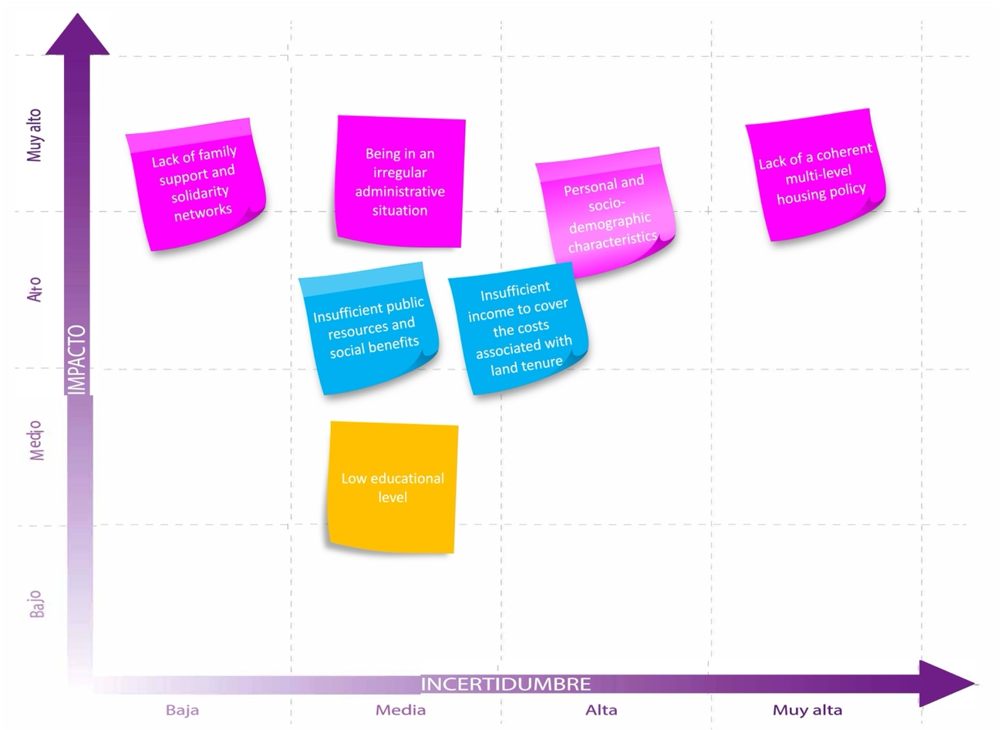
Source: own elaboration
Participants were finally engaged in structured scenario planning. Groups were asked to explore how the previously mapped factors could evolve individually in alternative future trajectories, each with distinct effects on society, institutions, and individuals.

3.3. Assessing factors
In the second workshop the evolution of each independent factor was put in common with the rest of the factors, starting from the ones identified as the most important. See Figure 2.

Figure 2. “Liquid Housing Lab”. Factors cross-impact analysis.
Lack of a coherent multi-level housing policy
Personal and socio-demographic characteristics
Insufficient public resources and social benefits
Insufficient income to cover the costs associated with land tenure
Bureaucracy and digitalisation
Low educational level
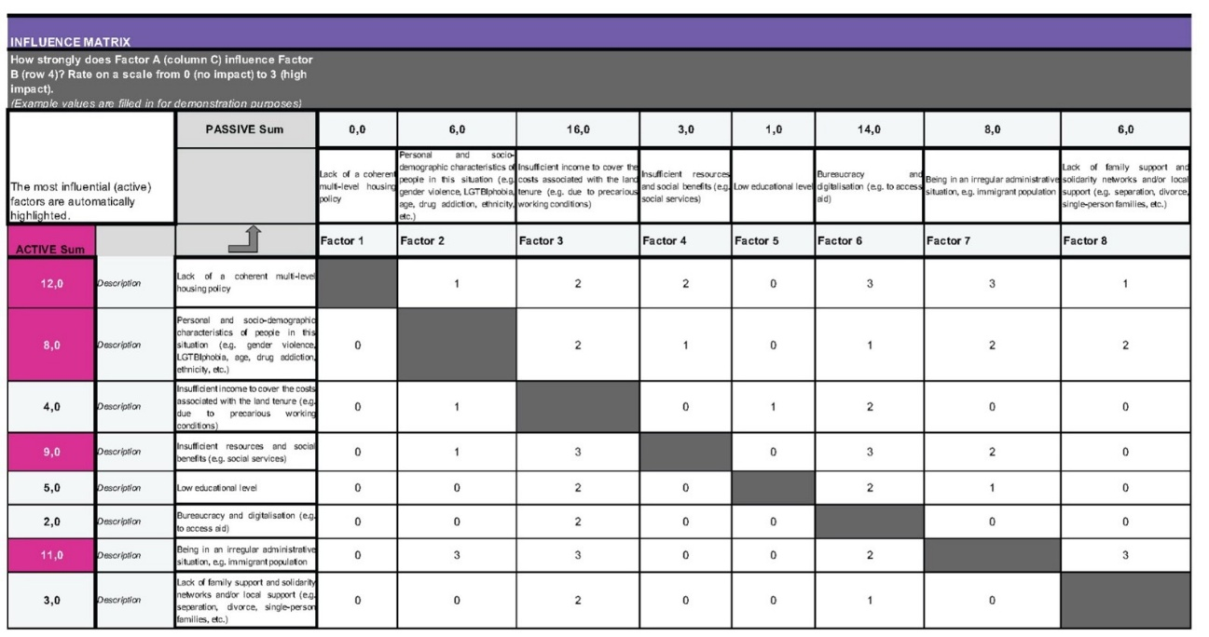
Source: own elaboration
The objective was to generate plausible scenarios based on logical combinations of the possible developments of the key factors identified in the first workshop. The outcome was as follows:
1) Scenario 1 shows greater invisibility and social exclusion, a greater percentage or spectrum of vulnerable groups without access to housing and in situations of hidden homelessness, an increase in the current profiles (mental health, drug addiction, etc.), so that the group susceptible to falling into a situation of hidden homelessness increases, an impact on the formation of new families, with special relevance in the birth rate, and a lower rate of youth emancipation, negative effects on family units (an increase in unwanted loneliness, the child population at risk and mental problems), and bureaucracy and administrative delays making it difficult for example to deliver social housing or the processing of public benefits. The participants argue that the precarisation of housing affects all groups across the spectrum, so the low educational level seems to have less importance in this scenario.
With respect to the conversations held in the group, the evolution towards an increasingly plutocratic society is highlighted, with a drastic increase in the number of poor and excluded people with no possibility of change. In this way, everyone loses, because a society that does not prosper always loses. In addition, the impact at the institutional level is very significant: the transfer of responsibilities from the Public Administration to the third sector, which causes an increased workload; at the level of neighbourhood associations, there is growing insecurity and an increase in more visible homelessness, while at the same time the problems in condominiums increase. Two possible scenarios at the citizen level are highlighted, considering the increase in the homeless phenomenon: 1) new social networks of self-help between families, associations, municipalities, etc.; and 2) greater individualism and degeneration of the urban, social and physical environment as major forms of social exclusion. Scenario 1 was summarized as follows: "See you in the park bench: the precariousness of housing in all social sectors".

Figure 3. Scenario 1. Source: own elaboration

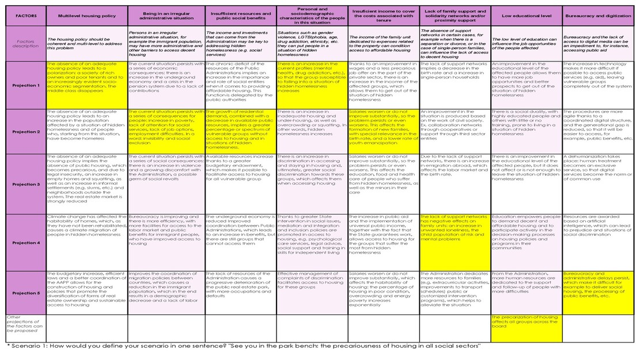
2) Scenario 2 shows a similar projection: greater invisibility and social exclusion, a greater percentage or spectrum of vulnerable groups without access to housing and in situations of hidden homelessness, an increase in discrimination in accessing and staying in housing, this having an impact on the formation of new families, with special relevance in the birth rate, and a lower rate of youth emancipation, an increase in unwanted loneliness and vulnerable groups completely out of the system due to the increase in technology. The participants the low educational level seems to have no importance in this scenario, in line with the participants in Scenario 1.
As it might be seen, Scenario 1 and Scenario 2 are similar they consider 5 out of 7 factors to evolve in the same way. This suggests that the projection of the first factor—whether it follows a more favourable (divergent) trajectory or an expected continuation of current trends—directly influences the overall scenario development. They differ in the evolution of the factor “Personal and sociodemographic characteristics of the people in this situation”, as well as in the factor “Bureaucracy and digitization”.
With respect to the conversations held in the group, it is considered that it affects society as a whole, since it increases vulnerability, social discrimination, urban degradation, insecurity, mental health and conflict. Equally, it is considered that there is no winner: society and, especially, the most vulnerable groups lose. Precisely, housing and social exclusion of citizens (with an increase in inequality) is emphasized. In particular, the scenario has a negative impact on the Public Administration, which must attend to more users that include more social groups. The same happens with entities of the third sector.
Scenario 2 was summarized ironically as follows: “Appropriate housing policies promote the right to adequate and decent housing”.

Figure 4. Scenario 2. Source: own elaboration
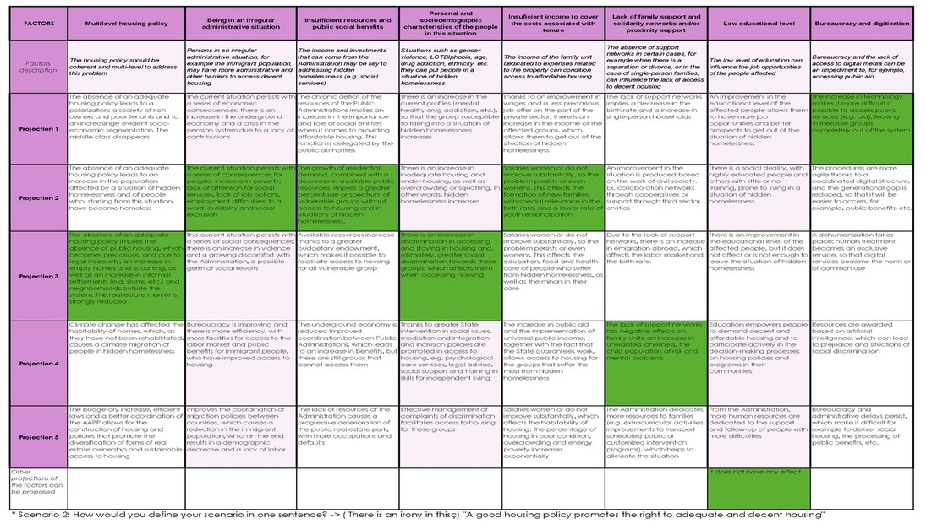

3) Scenario 3 shows a different projection for the factors taking into consideration that the most relevant factor (housing policies) evolves in a positive way, so there is a budgetary increase, efficient laws and a better coordination of the Public Administrations. It helps to improve bureaucracy, with more facilities for access to the labor market and public benefits for immigrant people; also, the increase of available resources makes it possible to facilitate access to housing for all vulnerable groups, and collaboration networks through cooperatives or support through third sector entities helps to involve civil society; this having an impact on the mediation and integration and inclusion policies are promoted. However, salaries worsen or do not improve substantially, which affects the habitability of housing: the percentage of housing in poor condition; and even procedures are more agile, a dehumanization takes place.
With respect to the conversations held in the group, the society wins in this scenario, in particular those belonging to the middle class. However, it is pointed out that there are always people out of the system. In addition, the impact at the institutional level is very significant: both the public administration and the third sector may offer better support; at the level of neighborhood associations, there is less insecurity, and a positive impact on condominiums (less squatters) is highlighted. At the citizen level, a positive impact would take place, even though the expected less quality of the housing stock. Scenario 3 was summarized as follows: “The illusion of reaching 2040".

Figure 5. Scenario 3. Source: own elaboration
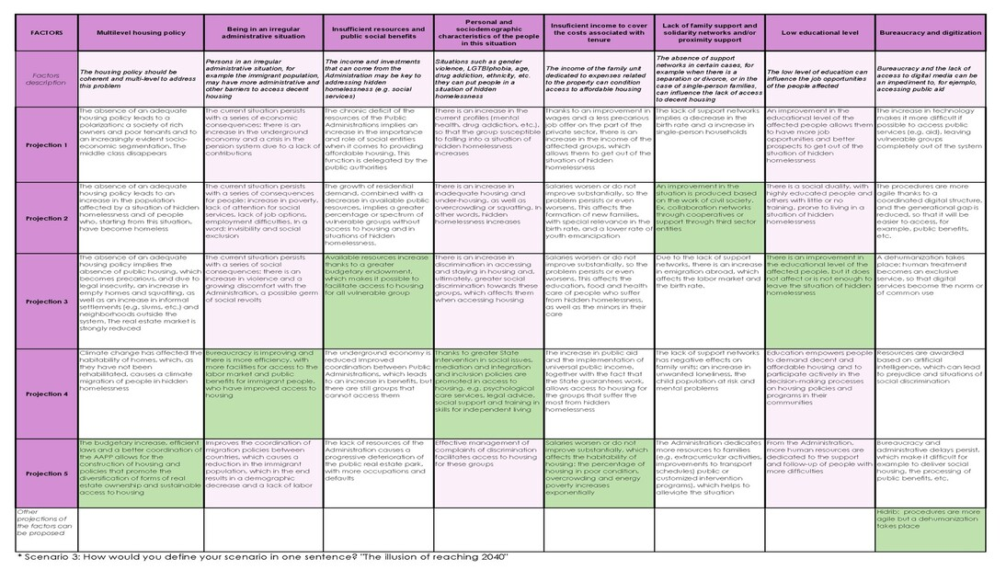

4) Scenario 4 was developed by the local team to provide a different perspective from the scenarios discussed in the focus groups. This scenario begins with the following projection: climate change has affected the habitability of homes, which, due to a lack of rehabilitation, leads to climate-induced migration among people experiencing hidden homelessness. As wages stagnate or decline, housing habitability worsens, resulting in a sharp increase in poorly maintained housing, overcrowding, and energy poverty. This situation triggers several social consequences: there is a rise in violence, growing public dissatisfaction with the government—potentially sowing the seeds of social unrest—and a steady deterioration of the public housing stock, including more squatting, evictions, substandard living conditions, and overcrowding. Due to the absence of support networks, emigration abroad increases, impacting the labor market and birth rate. While the affected population may attain a higher level of education, this is insufficient to overcome the condition of hidden homelessness. Bureaucratic hurdles and administrative delays persist, making it difficult to access social housing, process public benefits, and address other essential needs. Scenario 4 was summarized as: "The importance of adequate housing”.

Figure 6. Scenario 4. Own elaboration
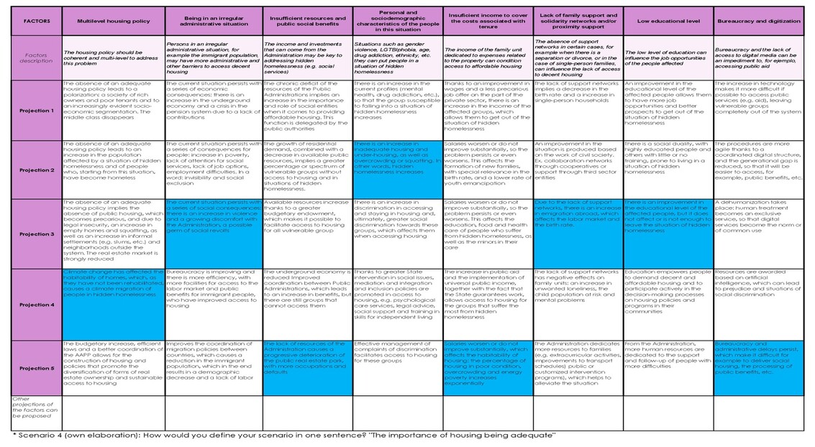
3.4. Prioritising policy solutions
The final workshop (January 2025) shifted from analysis to design bringing together 20 participants from different institutions. 20 preliminary policy proposals—based on project research, international best practices, and input from previous workshops—were discussed and grouped into five thematic categories: Housing Policies, Cohabitation Initiatives, Governance, Social Housing Management, and Integration & Training. See in this sense Table 2.

Table 2. List of policy options.

Nº | Policy | Policy description
1 | Fiscal framework | Develop a fiscal framework aimed at: promoting an increase in the supply of affordable rental housing (for owners or tenants); facilitating new construction (e.g. through reforms in building permit procedures); supporting rehabilitation and energy efficiency improvements; and enabling access to homeownership.
2 | Diversity of housing tenures | Encouraging alternative forms of tenure to ownership and renting: temporary ownership or shared ownership? Housing cooperatives with ownership or leasehold? Social rental? Co-living units with private rooms of 6m2 sharing common elements? Temporary local accommodation, made using industrialised methods from recycled shipping containers?...
3 | Promoting co-living initiatives | Promoting initiatives for co-living in solidarity between young professionals aged 25 to 35 and people in very precarious living conditions (Home for All Alliance, Denmark) / Access to student housing for young people who want to become students in the “near future” (Lazare co-living project, Paris) / Intergenerational co-living experiences.
4 | Mobilisation of empty housing | Mobilisation of empty housing from private owners to increase the supply of social rental housing. Private mechanisms such as rent-based rehabilitation, positive incentives (e.g. subsidies or guarantees in exchange for allocating properties to social rental housing), or negative incentives (e.g. sanctions or expropriations).
5 | Budget increase | Guarantee a sufficient part of the GDP to finance housing policies. More construction and acquisition of housing? More aid to families for paying rent? More staff from the City Council and Social Services? More aid for rehabilitation?
6 | Cooperation between organisations at local level | Local and/or regional integrated strategy to reduce hidden homelessness and thus facilitate cooperation between the various organisations and channel a local vision of shared support for these people.
7 | Specialised advice on housing | Specialised advice service on housing, e.g. late payment of rent, drug use, mental health problems and poor maintenance of flats, as well as various cultural conflicts between neighbours.
8 | Observatory on hidden homelessness | Create an observatory/body that allows us to understand the reality of the problem of hidden homelessness.
9 | Promote social, cultural and political participation | Promote the social, cultural, socio-economic, and political participation of individuals, for example, by facilitating access to mainstream leisure, cultural, and sports activities and enabling their active involvement in public housing policy processes.
10 | Measures against evictions | Avoiding losing housing through eviction is just as important as access to housing. It is essential to adopt effective measures to prevent, deal with and respond to evictions when vulnerable groups are involved. Through... help with rent or mortgage payments? legal moratoriums on evictions? advisory services? improving dialogue between social services and courts?
11 | Housing as a subjective right | Recognise the right to housing as a subjective right, either in the constitution or in the country's legislation, and clearly define the responsibilities of the different levels of public authority in housing matters (including regions, provinces and municipalities) / At local level, agreement signed by political leaders and public housing managers, so that the City Council establishes a housing guarantee for people in a situation of hidden homelessness.
12 | Role of third sector entities | Promote the participation of entities from the social third sector and/or the social economy in the promotion and management of housing solutions and community alternatives for coexistence aimed at people in a situation of serious residential exclusion.
13 | Educational and training resources | Develop educational, training and socio-labour resources specifically aimed at people in a situation of serious residential exclusion and promote active employment policies that take into account their needs.
14 | Registration policy | To promote the registration (sometimes fictitious) of people residing in the municipality and facilitate their administrative regularization, thus avoiding indirect discrimination by the Administration.
15 | Collaboration networks | Strengthen emancipation and support programmes in the transition to adult life aimed at young people, migrants or natives, without family references.
16 | Awareness campaign | Promote activities aimed at raising public awareness about the problem of hidden homelessness, e.g. to combat discriminatory practices in the tenant selection process. Role of public entities? Of private entities?
17 | Reduce the digital divide | Promote policies to reduce the digital divide: training programmes in digital skills? More infrastructure? Easy access via Wi-Fi networks in public areas, etc.?
18 | Protocol for young people under guardianship | Have a protocol for young people under guardianship when dealing with deinstitutionalisation. Articulate active measures that help the process of transition of adolescents towards an independent life.
19 | Centralisation of services | Centralising all needs and problems related to housing and hidden homelessness in a single centre of attention in the municipality.
20 | Role of property managers | Property managers can identify the communities of property owners in the municipality where vulnerable people, the elderly or those with mobility problems reside, and encourage the creation of support networks and help with problems of accessibility, energy efficiency, etc. in collaboration with the municipality.

Source: own elaboration
Participants validated these policy options in focus groups, prioritized them based on strategic criteria (impact, feasibility, scalability, cross-sectoral relevance), and identified necessary preconditions for implementation. The various policies are perceived differently depending on the scenario presented. They can be categorised as Structural (Core Strategy), Supportive (Supporting Strategy), or Counterproductive/with Limited Effects (Counter-productive). Generally, policies are perceived as supportive strategies in Scenario C, with few considered structural. This may be due to Scenario C's more positive evolution compared to Scenarios A and B, leading to the perception that many structural policies are already fully or partially implemented. The same may be said concerning Scenario D, as the starting point is different from Scenarios A and B, i.e. it focuses more on the impact of climate change on the habitability of homes and on the persons living there.
Certain policies are identified as structural across all three scenarios (8, 12 and 19) and other policies are deemed structural only in Scenarios A and B. These should also be considered essential for achieving resilience in this field, as they pertain to the more adverse scenarios (policies 1, 2, 4, 5 and 14). Some policies consistently play a secondary or supportive role across all three scenarios (policies 7, 15, 16 and 18) and divergences are noted in the assessment of certain policies (3, 9, 11 and 17). These are perceived as supportive or having limited effects, potentially influenced by scenario evolution. For instance, Policy 3 is seen as impacting emancipation and birth rates—issues identified in the scenario's progression. Policy 9 is considered necessary for identifying needs rather than providing solutions and Policy 11 requires resources to be operational, which are scarce in Scenario B. See Figure 7.

Figure 7. Wind tunnelling
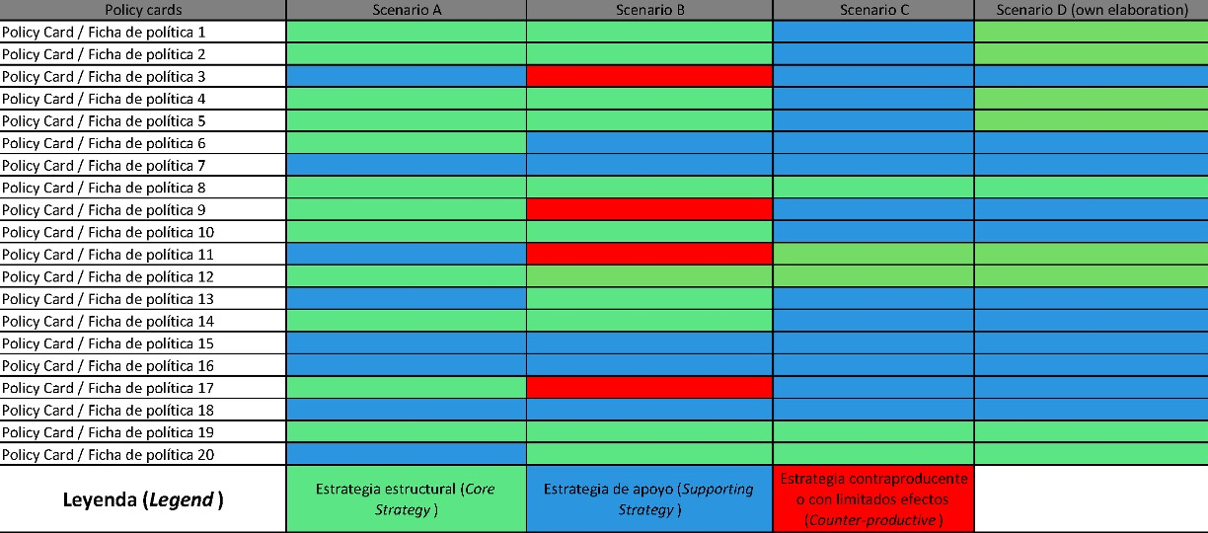
Source: own elaboration

4. Conclusions and recommendations
The experience of this study demonstrates the necessity, complexity, and opportunity inherent in addressing the challenges of “liquid housing” through innovative, participatory policy processes. The empirical evidence collected confirms that liquid housing—encompassing squatting, overcrowding, unregulated subletting, and substandard dwellings—is not a marginal phenomenon but a central dynamic shaping the housing market of Tarragona. Survey findings revealed that one in three residents is aware of squatted homes, while substantial proportions identified families at risk of eviction, energy poverty, or conditions of severe overcrowding. Even the low participation of the target groups, such figures expose the limitations of conventional statistics and reinforce the urgency of targeted, informed policy action.
Central to the study’s approach has been the explicit recognition of liquid housing as a complex, multi-causal, and context-specific phenomenon. The diversity of groups affected—ranging from migrants and young people to single mothers and older adults—demands that policies move beyond one-size-fits-all measures in favor of finely tuned, group-sensitive intervention. The diagnostic process highlighted how structural drivers (unemployment, income precarity, welfare gaps) intersect with legal and social factors (irregular status, lack of support networks), producing housing trajectories marked by instability, invisibility, and exclusion. In addition, systemic constraints—rooted in Spain’s multi-level governance framework—continue to limit the capacity for transformative change at the municipal level. While some policies (e.g. service centralization, awareness, quick interventions) fit within the scope of local competences, others (such as fiscal reform, regulation of vacant units, and major budgetary expansion) are dependent on powers held by Autonomous Communities or central government. This points to the urgent need for vertical policy integration, whereby local innovation is both enabled and scaled by supportive regulatory and financial frameworks at higher levels of government.
The policy co-creation process—built on three participatory workshops and ongoing stakeholder engagement—emerged as both a technical method and an ethical commitment. By combining scenario-based foresight, inclusive diagnostics, and iterative policy validation, the study succeeded in building collective intelligence and legitimacy for proposed measures. Workshops revealed deep divides, notably between the vision of housing as a right and as an economic asset, but achieved inclusive consensus on both the diagnosis of causes and the avenues of response. Policies were grouped into five coordinated areas: housing regulations, social integration, governance, social housing management, and integration and training—reflecting the multi-dimensionality of the problem and the strengths of cross-sectoral engagement.
The findings thus contribute to three levels of debate: a) conceptually, by refining the discussion on precarious housing through the category of liquid housing; b) methodologically, by demonstrating the added value of collaborative and foresight-based approaches in housing research; and c) practically, by offering insights that can inform both local governance in intermediate cities and broader housing policy frameworks. In this regard, several recommendations can be made for policymakers and practitioners:
- Institutionalize continuous, participatory data collection on hidden homelessness, leveraging both formal surveys and community knowledge.
- Foster multi-level governance alignment, advocating for greater municipal competences, co-financing, and regulatory harmonization for housing policy.
- Expand inclusive, scenario-based co-creation methodologies, investing in the training of facilitators and secure, accessible venues to maximize participation of all affected groups.
- Centre diversity, rights, and dignity in policy design, ensuring that interventions are sensitive to the intersectional vulnerabilities that drive housing exclusion.
- Emphasize scalability and adaptability by documenting best practices and facilitating peer learning between cities, regions, and states.

5. Acknowledgments
I would like to thank the European project FutuResilience (European Union’s Horizon Europe research and innovation programme under gran agreement No. 10109445, https://futuresilience.eu) for its support in carrying out this work.

List of references
Bank of Spain (2022). Informe Anual. https://www.bde.es/f/webbe/SES/Secciones/Publicaciones/PublicacionesAnuales/InformesAnuales/22/Fich/InfAnual_2022.pdf.
Bauman, Z. (2000). Liquid Modernity. Polity Press.
Belfield, A. & Petrescu, D. (2024). Co-design, neighbourhood sharing, and commoning through urban living labs. CoDesign, 21(2), 171–194.
Brysch, S. L. et al. (2023). The process of value setting through co-design: the case of La Borda, Barcelona. CoDesign, 20(3), 405–421. https://doi.org/10.1080/15710882.2023.2277724.
Bulkeley, H. et al. (2016). Urban living labs: Governing urban sustainability transitions. Current Opinion in Environmental Sustainability, (22), 13-17. https://lup.lub.lu.se/search/files/27601647/Bulkeley_et_al._2017.pdf.
Cox, M. & Haar, K. (2020). Platform Failures: How Short-Term Rental Platforms like Airbnb fail to cooperate with cities and the need for strong regulations to protect housing. https://left.eu/issues/publications/platform-failures-how-short-term-rental-platforms-like-airbnb-fail-to-cooperate-with-cities-and-the-need-for-strong-regulations-to-protect-housing/.
Creswell, J.W. (2014). Research Design: Qualitative, Quantitative, and Mixed Methods Approaches. Sage Publishing.
Creswell, J.W. & Plano Clark, V.L. (2018). Designing and Conducting Mixed Methods Research. Sage Publishing.
Caballé, G. et al. (2020). L’Habitatge compartit a Barcelona i la seva adequació als estàndards internacionals. Informe para el Síndic de Greuges de Barcelona. https://www.sindicaturabarcelona.cat/wp-content/uploads/2021/11/Informe_OK_web.pdf.
Debrunner, G. et al. (2024). Housing Precarity in Six European and North American Cities: Threatened by the Loss of a Safe, Stable, and Affordable Home. Journal of the American Planning Association, 90(4), 610–626. https://doi.org/10.1080/01944363.2023.2291148.
Deleu, H. et al. (2023). Hidden Homelessness: A Scoping Review and Avenues for Further Inquiry. Social Policy and Society, 22(2), 282–298.
De Inés, A. et al., Diagnosi 2019. El sensellarisme a Barcelona. Evolució i joves en situació de sensellarisme. Xarxa d’Atenció a Persones sense llar de Barcelona. https://www.barcelona.cat/barcelonainclusiva/ca/2019/11/Diagnosi_sensellarisme_2019_WEB.pdf.
Entitats Catales d'Acció Social (2024). L’empadronament a Catalunya: vulneració d’un dret i una obligació. https://acciosocial.org/wp-content/uploads/2024/08/Sondeig_Lempadronament-a-Catalunya_juny-2024.pdf.
Ferreri, M. et al. (2016). Living precariously: property guardianship and the flexible city. Transactions of the Institute of British Geographers, 42(2), 246-259. https://doi.org/10.1111/tran.12162.
Fundación FOESSA (2022). Evolución de la cohesión social y consecuencias de la COVID-19 en España. https://www.caritas.es/main-files/uploads/sites/31/2022/01/Informe-FOESSA-2022.pdf.
Gandarias Goikoetxea, I. et al. (2024). Sinhogarismo encubierto en mujeres en situación de exclusión social grave: Una investigación exploratoria. Revista Prisma Social, 44, 105–128. https://revistaprismasocial.es/article/view/5311.
Generalitat de Catalunya (2020). Pla Estratègic de Serveis Socials 2021-2024. Departament de Treball, Afers Socials i Famílies. https://dretssocials.gencat.cat/web/.content/03ambits_tematics/15serveissocials/pla_estrategic_serveis_socials/Pla_estrategic_serveis_socials_catalunya_NOU/01_Plana_principal/1.-2020-12-29-Pla-estrategic-de-serveis-socials-2021-2024.pdf.
Goodall, Z. et al. (2023). Housing policy and non-commercial shared housing in the private rental sector: a scoping review. Housing Studies, 39(11), 2919–2937. https://doi.org/10.1080/02673037.2023.2238633.
Grundström et al. (2024). Sharing housing: a solution to – or a reflection of – housing inequality? Journal of Housing and the Built Environment, (39), 2049–2068. https://doi.org/10.1007/s10901-024-10130-9.
The Global Risks Report (2023). 18th Edition. https://www3.weforum.org/docs/WEF_Global_Risks_Report_2023.pdf.
Hernández-Pedreño, M. et al. (2024). Riesgo social de las personas en exclusión residencial: Un análisis multidimensional. Revista Prisma Social, (46), 257–290. https://revistaprismasocial.es/article/view/5312.
Institut Cerdà (2023). L'ocupació il·legal d'habitatges es xifra en 78.000 a Espanya. https://www.icerda.org/ca/locupacio-il·legal-dhabitatges-es-xifra-en-78-800-avui-a-espanya/.
Instituto de Derechos Humanos Gregorio Peces-Barba de la Universidad Carlos III de Madrid (2023). Estudio sobre los procesos de desinstitucionalización y transición hacia modelos de apoyo personalizados y comunitarios. Personas con discapacidad. Ministerio de Derechos Sociales. https://estudiodesinstitucionalizacion.gob.es/wp-content/uploads/2024/01/Estudio-Transversal.pdf.
Instituto de la Juventud (2023). Exclusión residencial entre las personas jóvenes: desafíos y propuestas para una sociedad más inclusiva, Revista de Estudios de Juventud, 127. https://www.injuve.es/sites/default/files/adjuntos/2024/01/revista-estudios-juventud-127-sinhogarismo-exlusion-residencial.pdf.
Kenna, P. et al. (2016). Pilot project "Promoting protection of the right to housing: homelessness prevention in the context of evictions". European Commission, Directorate-General for Employment, Social Affairs and Inclusion, Publications Office.
Manjikian, M. (2013). Securitization of Property Squatting in Europe. Routledge.
McCarthy, L., & Parr, S. (2022). Is LGBT homelessness different? Reviewing the relationship between LGBT identity and homelessness, Housing Studies, 40(7), 1525–1544. https://doi.org/10.1080/02673037.2022.2104819.
Nasarre-Aznar, S. (2025). Los retos de la vivienda en Europa. Especial atención a la evolución de la situación en España, PPE. https://sergionasarre.eu/wp-content/uploads/2025/03/snasarre-retos-de-la-vivienda-en-europa-2025.pdf.
Nasarre-Aznar, S. et al. (2021). Concrete Actions for Social and Affordable Housing in the EU. FEPS. https://feps-europe.eu/publication/775-concrete-actions-for-social-and-affordable-housing-in-the-eu/.
Nasarre-Aznar, S. (2020). Los años de la crisis de la vivienda. Tirant lo Blanch.
Onrubia Fernández, J. (2010). Vivienda e inmigración en España: situación y políticas públicas’, Presupuesto y Gasto Público, 61, 273-310. https://www.ief.es/docs/destacados/publicaciones/revistas/pgp/61_15.pdf.
Polk, M. (2015). Transdisciplinary co-production: Designing and testing a transdisciplinary research framework for societal problem solving. Futures, (65), 110-122. https://doi.org/10.1016/j.futures.2014.11.001
Provivienda (2023). Prevención y atención de la exclusión residencial. Factores explicativos. https://www.provivienda.org/wp-content/uploads/prevencion-y-atencion-de-la-exclusion-residencial.pdf.
Ratcliffe, J. (2000). Scenario building: A suitable method for strategic property planning? Property Management, 18(2), 127-144. https://arrow.tudublin.ie/cgi/viewcontent.cgi?article=1015&context=futuresacart.
Reason, P. & Bradbury, H. (2008). The SAGE Handbook of Action Research: Participative Inquiry and Practice. Sage Publishing.
Ribera-Almandoz et al. (2022). ‘Our home, your home?’ The precarious housing pathways of asylum seekers in Catalonia. Housing Studies, 39(7), 1678–1701. https://doi.org/10.1080/02673037.2022.2141202.
Sánchez-Sierra Ramos, M. & Flores Martos, R (2022). Brecha digital: reproducción virtual de las desigualdades sociales, in: Fundación FOESSA, Evolución de la cohesión social y consecuencias de la COVID-19 en España, 187-227.
Schmid, C. U. (2018). Tenancy Law and Housing Policy in Europe. Towards Regulatory Equilibrium. Edward Elgar Publishing, Elgar Land and Housing Law and Policy series.
UN-Habitat (2019). The Right to Adequate Housing. United Nations Human Settlements Programme.
Valenzuela-Garcia, H. et al. (2021). The Relational Vulnerability of People Experiencing Multiple Exclusion Homelessness (MEH) in Spain, International Journal of Environmental Research and Public Health, 18(19), 10275. https://doi.org/10.3390/ijerph181910275.
Villa-Rodríguez, K. G. et al. (2023). Una aproximación a la exclusión residencial que afecta a las mujeres migrantes: el sinhogarismo oculto. Revista OBETS, 18(2), 397–418.
Waldron, R. (2021). Generation Rent and housing precarity in ‘post crisis’ Ireland. Housing Studies, 38(2), 181–205. https://doi.org/10.1080/02673037.2021.1879998.

https://www.un.org/en/about-us/universal-declaration-of-human-rights.
https://www.ohchr.org/en/instruments-mechanisms/instruments/international-covenant-economic-social-and-cultural-rights.
T. Pérez, Retratos de miseria de la vida en un cuartucho de alquiler en Barcelona, El Periódico, 27/05/2018, https://www.elperiodico.com/es/sociedad/20180527/la-vida-en-un-zulo-de-alquiler-en-barcelona-6827253.
https://ec.europa.eu/eurostat/web/interactive-publications/housing-2024#quality-of-housing.
https://www.feantsa.org/ethos.
The participants were the following: the Municipal Housing Office of the city council of Tarragona (SMHAUSA), the Municipal Institute of Social Services of Tarragona, neighbourhood associations of Tarragona, the association of Property Managers of Tarragona, the chamber of Urban Properties of Tarragona, housing developers, the municipal Mediation Service of Tarragona, the association Juventud i Vida, the association Tarragona Intercultural, the Bonanit foundation, Vincle (community support service of the Catalan Housing Agency), Càritas Interparroquial of Tarragona and Intress (Social Work and Social Services Institute).
https://www.ohchr.org/sites/default/files/Documents/Publications/WomenHousing_HR.PUB.11.2.pdf.
https://portal.mineco.gob.es/RecursosArticulo/mineco/economia/macro/Programa_Estabilidad/PE_22.pdf
Source: https://observatorisocial.tarragona.cat.
https://www.arrelsfundacio.org/en/.
https://fundaciomambre.org.
Reports such as HSP Publication: 50 out-of-the-box Housing Solutions for the Locked Out, 2019; Fondation Abbé Pierre, FEANTSA, and ASF, Ending the Criminalisation of Homelessness in Europe, 19-12-2024, or FOESSA, Informe sobre exclusión y desarrollo social en España, 2019, were taken into account.

